Vanier College

Faculty of Science and Technology

**GallerieM**

System Development

420-942-VA

Deliverable 04

2023-10-06

**Red Team**

Justin Elmourne

Florjan Blakaj

David Lafleur

Roy Aldner Labado

Seyed Ali Ashrafizadeh

We, the Red Team, certify that this assignment is our own work

I, David Lalfeur, student ID# 0110341, certify that I have contributed to this

deliverable, D.L.

I, Justin Elmourne, student ID# 1755556, certify that I have contributed to this

deliverable, J.E.

I, Florjan Blakaj, student ID# 2395017, certify that I have contributed to this

deliverable, F.B.

I, Roy Aldner Labado, student ID# 2395053, certify that I have contributed to this

deliverable, R.L.

I, Seyed Ali Ashrafizadeh, student ID# 2395024, certify that I have contributed to this

deliverable, A.S.

**Table of Contents**

**Overview 4**

**Description of Client 5**

**Business Problem 6**

**Apendecis 7**

Apendix 1 **7**

Apendix 2 **8**

Apendix 3 **11**

**Story Map 12**

# 

# 

# 

# **Overview**

GallerieM, is a local boutique situated in Montreal that specializes in handcrafted and personalized items, making it a top choice for events like weddings, anniversaries, and bridal showers. Their transition to an eCommerce platform comes with challenges such as maintaining a personal connection with customers, data security, competition, team training, and building a website. Selling handmade products adds complexity due to higher production costs and the need to convey the value of quality over mass-produced items.

Presently, GallerieM manages operations via Instagram and an Excel sheet to handle inquiries and custom product requests. They follow a creative process, including sketching, material acquisition, production, and delivery coordination, ensuring a personalized customer experience.

In the new system, there are three critical diagrams which include a flowchart, use case diagram with a description, and a class diagram. The flowchart visually represents the processes and interactions between administrators and users. While, the use case UML outlines the various interactions and activities involving users, administrators, and essential APIs. Lastly, The class diagram provides an overview of system components and their relationships.

# **Description of Client**

Located in the heart of Montreal, GallerieM is a standout boutique, renowned for its handcrafted and personalized items. Their vast portfolio, from tailor-made t-shirts and elegant mugs to detailed invitation cards and delightful baby attire, positions them as a top choice for events like weddings, anniversaries, and more intimate affairs such as bridal showers. GallerieM operates with a clear B2C focus, handling both individualized requests and larger bulk orders, always ensuring a personal touch in every piece.

GallerieM, doesn’t have any knowledge of programming but possesses a commendable understanding of digital tools. They’re proficient with Excel spreadsheets and using them for various business needs. Furthermore, they are efficient with email communication, ensuring smooth interactions with customers and suppliers. As the business seeks to expand its digital footprint with an eCommerce platform, their foundational computer skills will be an asset, although the technicalities of web development will be a new territory. Her in-house design craftsmanship and a keen eye for detail, combined with her digital proficiency, set GallerieM on a path of promising growth amidst a competitive market, particularly during peak seasons and significant occasions.

# **Business Problem**

There are some problems for most businesses when going online. However, five biggest challenges are:

* Maintaining personal connection with customers.
* Data collection and security.
* Battling and staying ahead of competition.
* Preparing and training the team for change.
* Building a website.

In addition, there are more problems when the product is handmade. The main disadvantages of selling handmade products are that having much higher production costs than similar products that are mass-produced, therefore, product’s prices will be higher. Then the business’ owner must get consumers to understand why the prices are higher and see the benefits of handmade products, otherwise, customers will buy the cheaper, mass-produced product.

Therefore, in the website it is necessary to focus on the quality, life time and other advantages compared to mass-produced products. Since there are special customers for these products on special occasions, targeting should also be focused on these people and on these occasions.

Another problem that exists for such businesses is not knowing the competitors. Anyone can do the same thing at home and become a competitor. Therefore, advertising for such jobs should be done with a lot of study and the virtual world should be taken care of in parallel and constantly to identify competitors.

# **Appendices**

**APPENDIX 1:**

**Process for Obtaining User Stories:**

It was a challenge to obtain the user stories since our client is also busy and we are in a very tight schedule. We have to make a scenario based on the requirements we have gathered. It was a good thing that we did a good job on gathering the requirements because we have enough data/information needed in the making of user story and user story map. We looked at the possible angles in the application and in the user. We have come up with 2 category user stories (admin and customer), and this is shown in the following appendix.

**APPENDIX 2:**

**User Stories and Tests:**

**FOR CUSTOMER**

**Search Products**

1. As a customer,

I want to browse products by category

so that I can quickly find what I'm interested in

ACCEPTANCE CRITERIA:

* The category selection should be intuitive and user-friendly.

1. As a customer,

I want to view detailed product information (including images, descriptions, most popular products)

so that I can make informed purchase decisions.

ACCEPTANCE CRITERIA:

* The product details page should provide comprehensive information.
* The most popular products should be clearly indicated and easy to access.

**Customize Products**

1. As a customer,

I want to be able to be given options to customize products (size, print, color)

so that I can choose my preference.

ACCEPTANCE CRITERIA:

* The customization options should be visually clear and easy to select.
* Changes to customization should be immediately reflected in the product's details

1. As a customer,

I want to message the seller for more options not seen online

to be able to cater my specific needs.

ACCEPTANCE CRITERIA:

* The platform should provide a user-friendly messaging system.

**Order Products**

1. As a customer,

I want to add products to my cart

so that I can purchase multiple items at once.

ACCEPTANCE CRITERIA:

* Adding items to the cart should be straightforward.
* The cart should display product names and quantities.

1. As a customer,

I want to view my cart

so that I could see the total price and adjust quantities.

ACCEPTANCE CRITERIA:

* The cart should be easy to access and navigate.
* Quantity adjustments should be reflected in real-time

1. As a customer,

I want to proceed to checkout

so that I can finalize my purchase.

ACCEPTANCE CRITERIA:

* The checkout process should have clear steps and instructions
* It should handle various payment methods securely.

1. As a customer,

I want to receive a confirmation email after placing an order

So that I can ensure that order was successful.

ACCEPTANCE CRITERIA:

* The confirmation email should be sent promptly
* It should contain all necessary order information.

**FOR ADMIN**

**Product Management**

1. As an admin,

I want to add new products to the website, including details, images, prices and new customizations,

so that customers can purchase them.

ACCEPTANCE CRITERIA:

* The product addition process should be straightforward.
* It should prevent incomplete submissions.

1. As an admin,

I want to edit or update product details

to ensure accuracy and relevancy.

ACCEPTANCE CRITERIA:

* Editing product details should be user-friendly and intuitive.
* Updates should immediately appear on the product pages.

1. As an admin,

I want to remove outdated or unavailable products

to keep the store inventory current.

ACCEPTANCE CRITERIA:

* Product removal should be a simple and reversible process.
* Removed products should no longer appear in search results.

**Order Management**

1. As an admin,

I want to view all customer orders

to track sales and manage inventory.

ACCEPTANCE CRITERIA:

* The order list should be organized and easy to access.
* Order details should be comprehensive.

1. As an admin,

I want to update the status of orders (e.g., processing, shipped, delivered)

to provide customers with accurate tracking information.

ACCEPTANCE CRITERIA:

* Status updates should be reflected in real-time.
* Customers should receive notifications when their orders change status.

1. As an admin,

I want to handle return and exchange requests

to ensure customer satisfaction.

ACCEPTANCE CRITERIA:

* The return/exchange process should be clearly documented.
* Customers should receive timely responses to their requests.

**Customer Management**

1. As an admin,

I want to view and manage customer orders

to support customers and resolve any account-related issues.

ACCEPTANCE CRITERIA:

* Accessing customer orders should be secure and well-documented.
* Customer details should be editable as necessary.

1. As an admin,

I want to contact customers directly (e.g., email)

to address inquiries or provide updates.

ACCEPTANCE CRITERIA:

* The email feature should be user-friendly and secure.
* Customers should receive important updates and responses promptly.

**Inventory Management**

1. As an admin,

I want to track inventory levels

to ensure products are in stock and reorder when necessary.

ACCEPTANCE CRITERIA:

* The inventory management system should be regularly updated.
* Restocking alerts should be clear and timely.

**APPENDIX 3:**

**Tools Used:**

JIRA Story Board for user story map.

# **STORY MAP**

**STORY MAP FOR CUSTOMER**

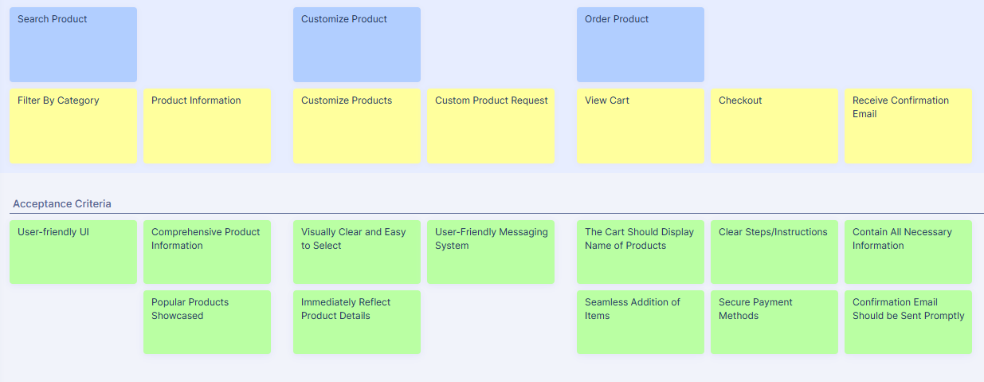

**STORY MAP FOR ADMIN**